**GANPAT UNIVERSITY**

**U.V.PATEL COLLEGE OF ENGINEERING & TECHNOLOGY**

**Department of Computer Science and Engineering**

**B.Tech 1ST Semester   Subject –esfp**

**First Name: harsh mehta      Enrollment Number: 9                 Stream :cba**

**Assignment  – 1/esfp                                                                           Date:27/08/2014**

**Q.1 Write a program to print ASCII values of all backslash characters and white space on screen in following format :**

**The ASCII value of ‘\t’ is : 9**

**Ans.1**

#include<conio.h>

#include<stdio.h>

void main()

{

int a;

float b;

clrscr();

a=15;

b=20.153000;

printf("%d",a);

printf("\t \t %2.6f",b);

printf("\n %d %2.6f",a,b);

printf("\n %d is an integer value and %2.6f is a float value ",a,b);

printf("\n %d \n %2.6f",a,b);

getch();

}

Q.2-Explain different data types available in C.

**Ans.2**-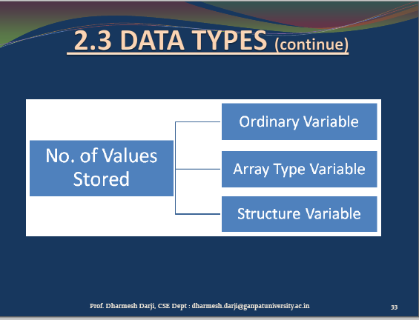

The C language provides many basic types. Most of them are formed from one of the four basic arithmetic type specifiers in C (char, int, float and double), and optional specifiers (signed, unsigned, short, long).

**Q.3 Explain about C Tokens in brief.**

**Ans.3**

In a C source program, the basic element recognized by the compiler is the "token." A token is source-program text that the compiler does not break down into component elements.  
  
Syntax  
  
token:keyword   
  
identifier constant string-literal operator punctuator  
  
The keywords, identifiers, constants, string literals, and operators described in this section are examples of tokens. Punctuation characters such as brackets ([ ]), braces ({ }), parentheses ( ( ) ), and commas (,) are also tokens.

**Q.4-Explain about backslash characters in C.**

**Ans.4**-backslash are used in the programming languages C and C++. backslash is a sequence of characters that does not represent itself when used inside a character or string literal, but is translated into another character or a sequence of characters that may be difficult or impossible to represent directly.

In C, all backslash consist of two or more characters, the first of which is the backslash, \: